
IN-COURSE ASSESSMENT (ICA) SPECIFICATION

Module Title:  System Design and Database | Module Leader: Dr Yar Muhammad
 | Module Code: CIS1018-N
Assignment Title: | Deadline Date: ICA 2: | 11-Jan-2023
SQL Database Portfolio
SQL Database Portfolio | Deadline Time: 4:00pm
 | Submission Method:
 | Online (Blackboard)
 | Middlesbrough Tower

Online Submission Notes:

- Please carefully follow the instructions given in this Assignment Specification.

- When Extenuating Circumstances (e.g. extension) has been granted, a fully completed and signed Extenuating Circumstances form must be emailed to scedt-assessments@tees.ac.uk or submitted to the School Reception.

Central Assignments Office (Middlesbrough Tower M2.08) Notes:

- All work (including media) needs to be secured in a plastic envelope or a folder and clearly marked with the student name, number and module title.

- An Assignment Front Sheet should be fully completed before the work is submitted.

- When Extenuating Circumstances (e.g. extension) has been granted, a fully completed and signed Extenuating Circumstances form must be emailed to scedt-assessments@tees.ac.uk or submitted to the School Reception.

FULL DETAILS OF THE ASSIGNMENT ARE ATTACHED

INCLUDING MARKING & GRADING CRITERIA

SQL TSQL03 Task – Querying with Select
- Writing Simple SELECT Statement:
  - Select all
Code:
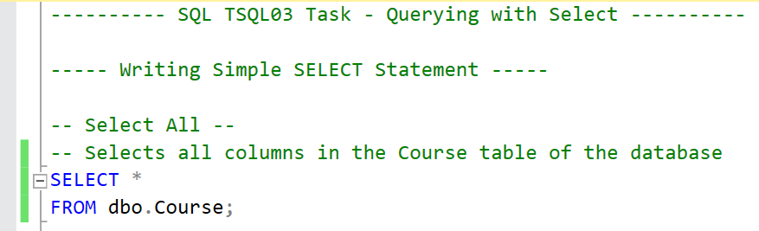

Table:
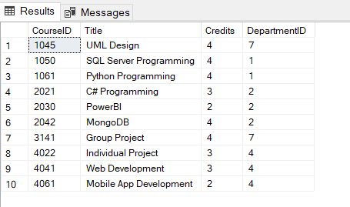

  - Select specific columns
Code:
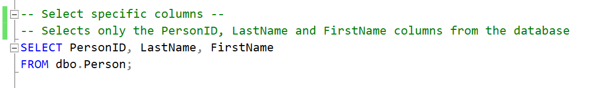

Table:
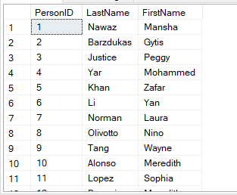

- Eliminating Duplicates with DISTINCT:

Code:
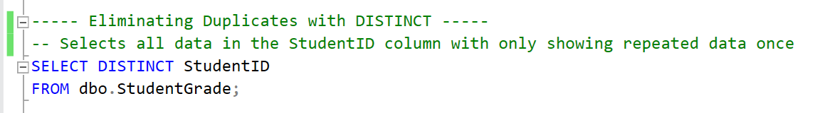

Table:
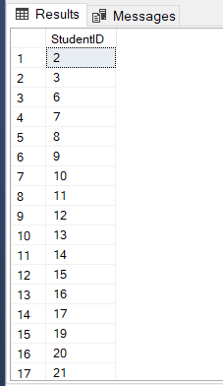

- Using Column and Table Aliases

Code:
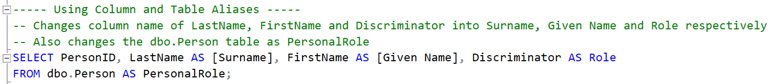

Table:
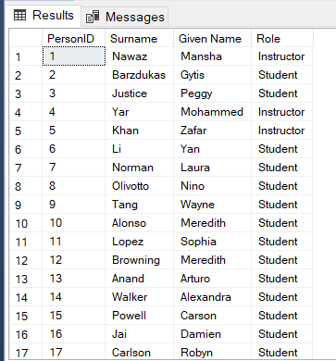

- Writing Simple Case Expressions

Code:
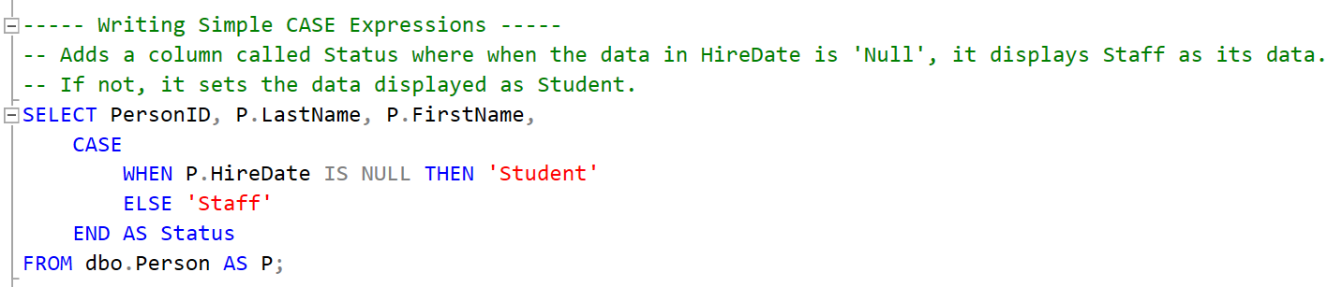

Table:
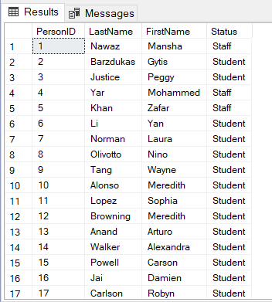

SQL TSQL04 Task – Querying with Multiple Tables
- Relating 2 or more tables – Joins
  - INNER

Code:
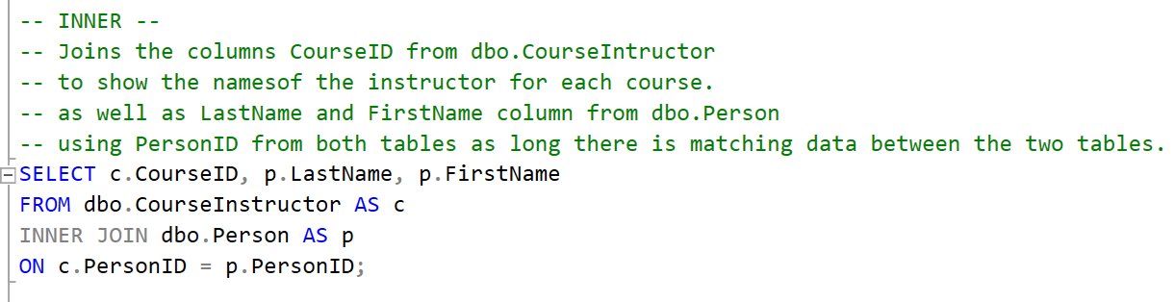

Table:
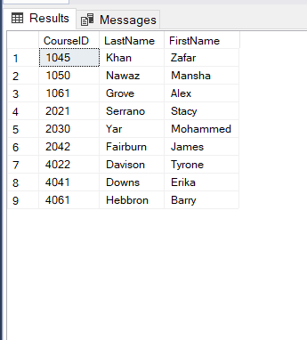

  - OUTER
Code:
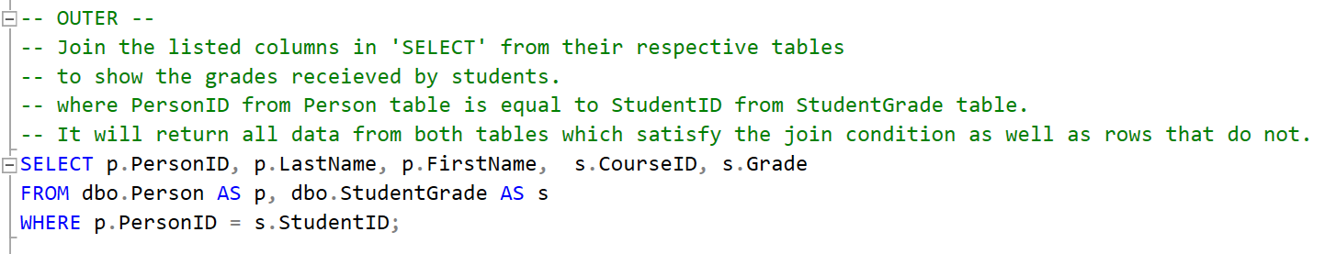
Table:
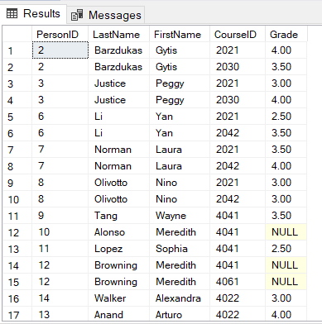
  - LEFT
Code:
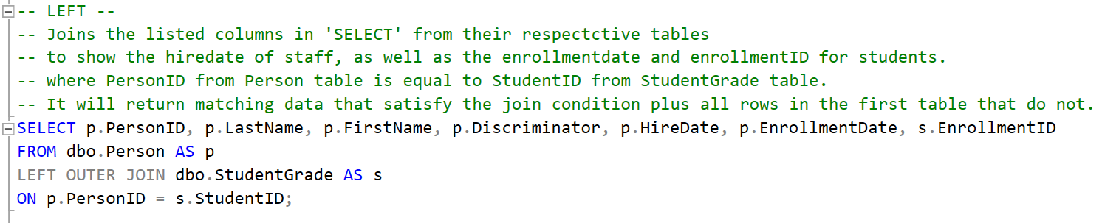

Table:
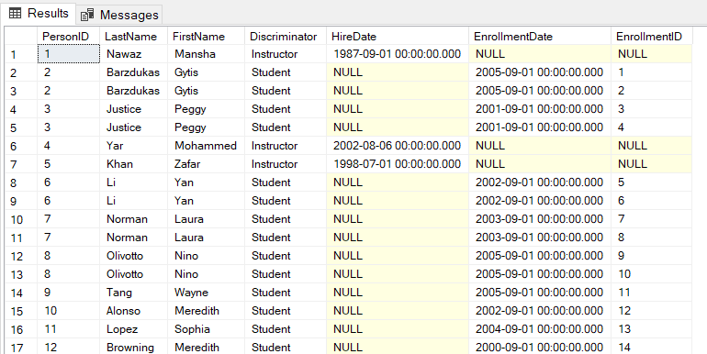

  - RIGHT
Code:
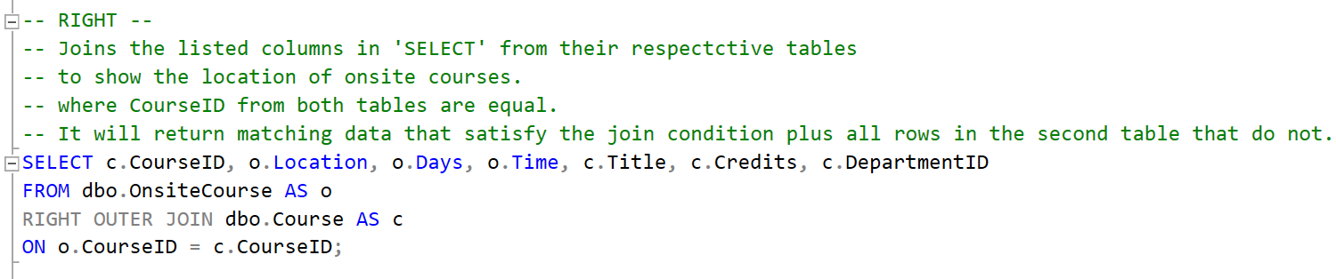

Table:
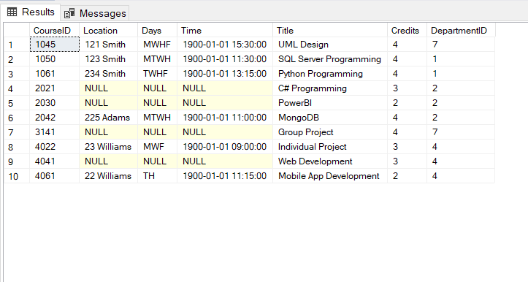

- Joining Multiple Tables – inner, outer and cross
Code:
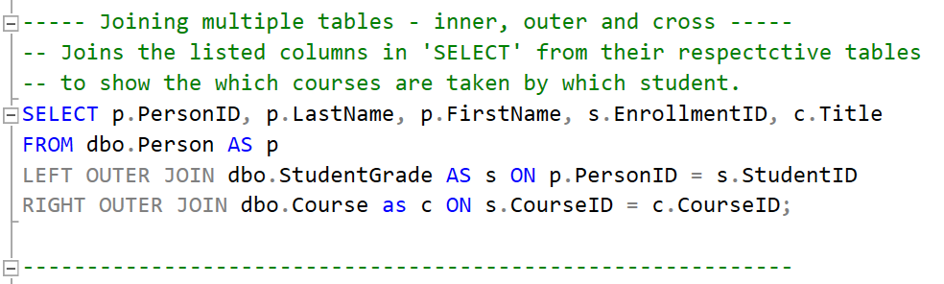

Table:
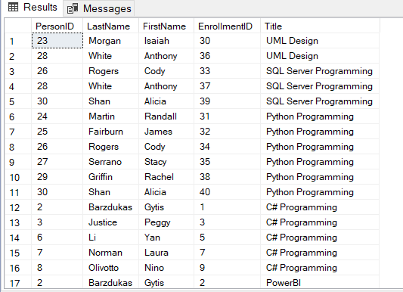

SQL TSQL05 Task – Sort and Filtering Data
- Sort with Order By
Code:
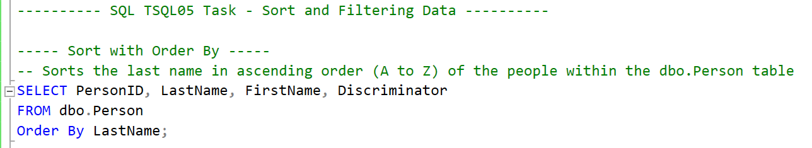

Table:
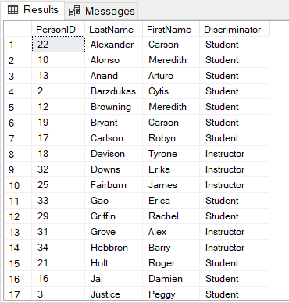

- Filter with Where By
Code:
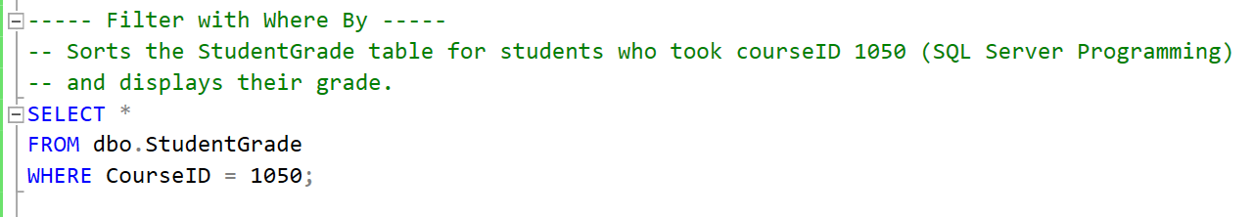
Table:
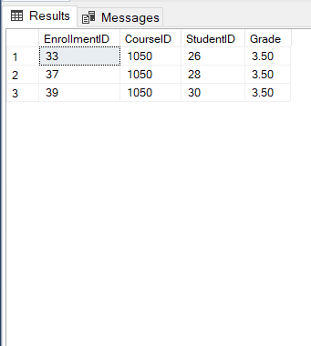
- Filter with top offset fetch
Code:
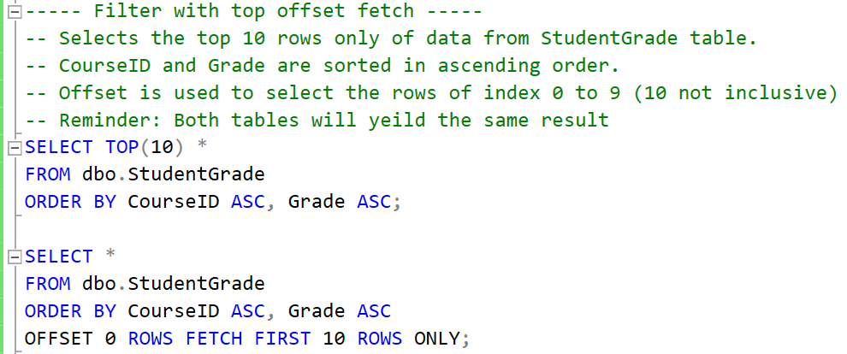
Table:
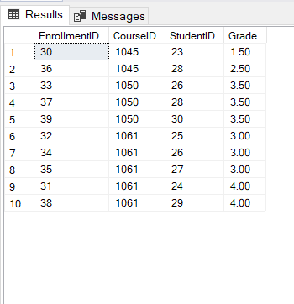

- Handling Null
Code:
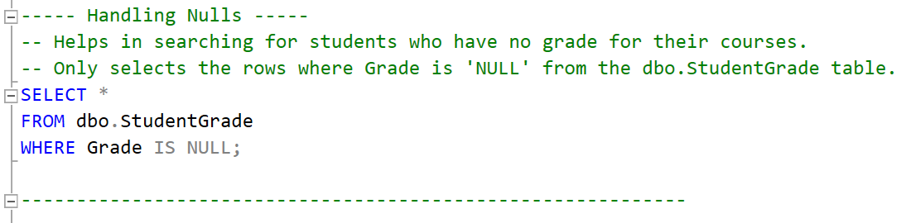

Table:
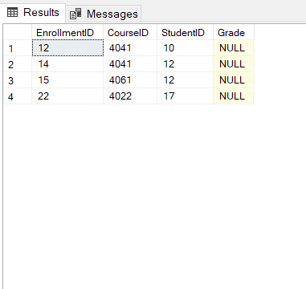
SQL TSQL06 Task – Working with SQL Server Data
- Conversion in a Query
Code:
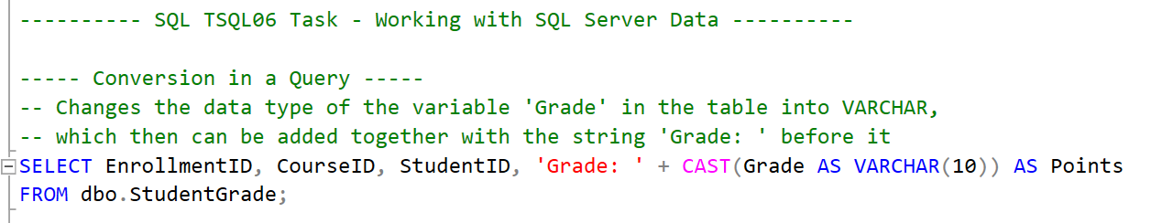
Table:
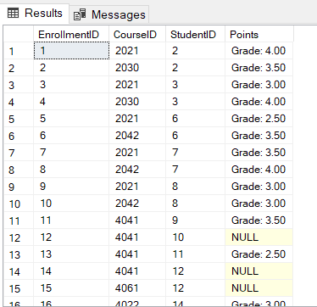

- Collation in a Query
Code:
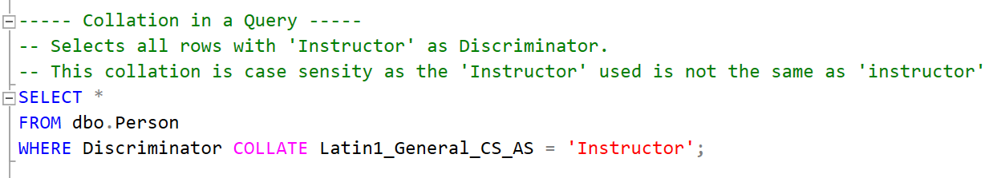
Table:
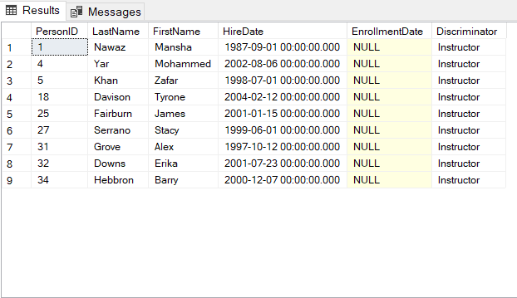

- Date and Time Functions
Code:
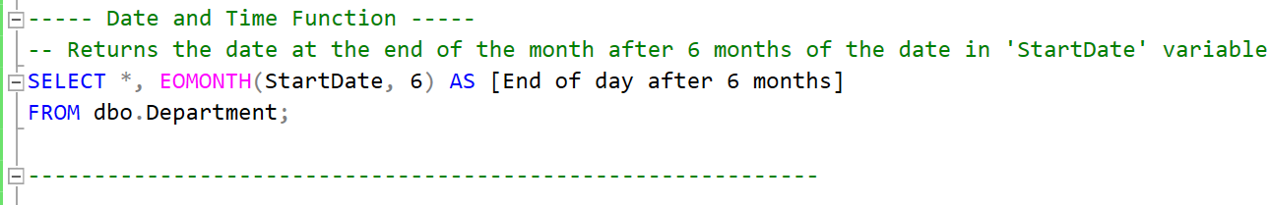

Table:
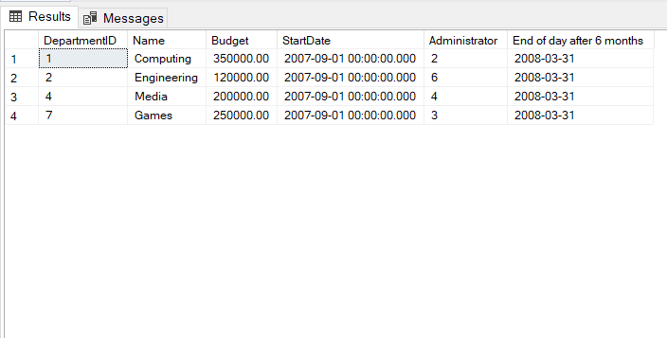

SQL TSQL07 Task – Using DML to Modify Data
- Adding Data to Tables
Code:
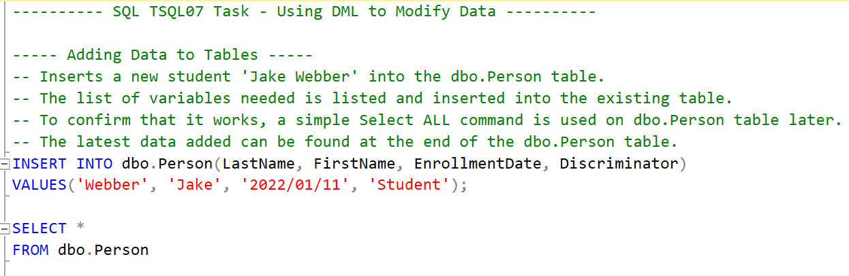

Table:
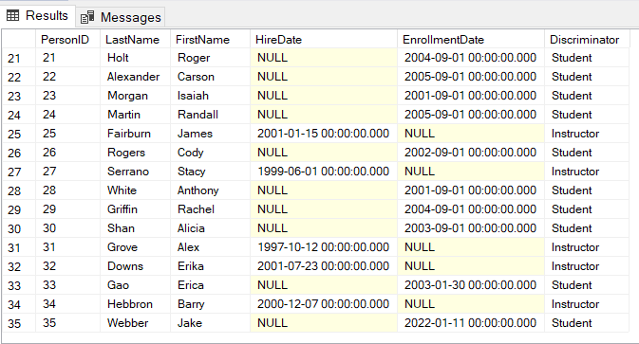

- Modifying and Removing Data
Code:
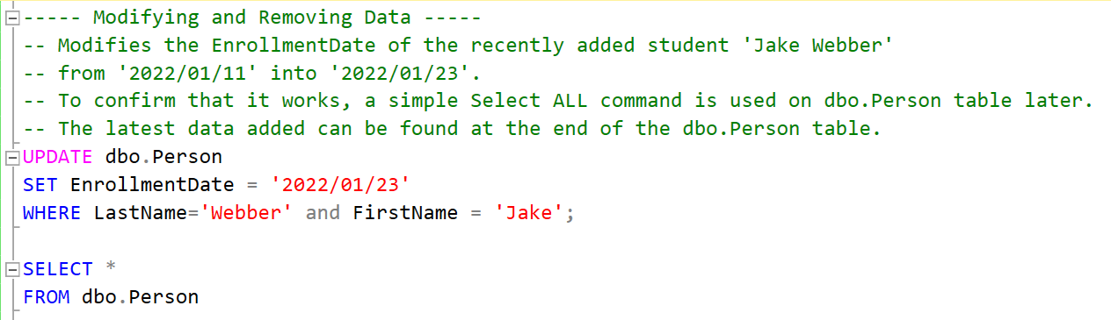

Table:
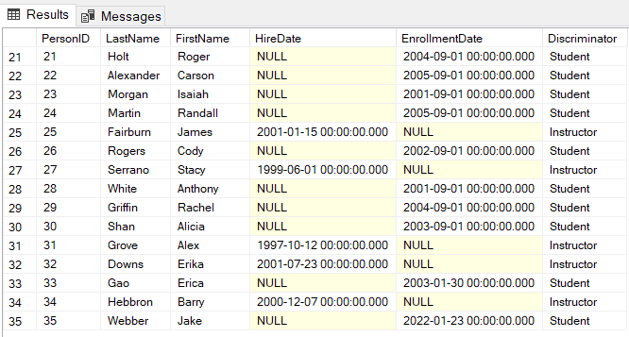

- Generating Automatic Column Values

Code:

Table:

Data Protection Legislation/Regulation and Security
Some legal considerations that need to be considered when implementing a web-bases eCommerce system is the possibility of the code or design of said system is plagiarised from other sources. If an open-source code/design is used, it should be credited on the system to its original designer as it is important to avoid possibilities of legal action to be taken onto the client. Moreover, it also shows the clients moral integrity in abiding by the law which in turn paints a better light on the client toward the general public as a company’s reputation is key to success since once tarnished, is difficult to rebound form.

A security measure that could be implemented to ensure that the data in the system is safeguard is by restricting the access of unauthorised individuals of the system. This could be implemented by having numerous stages of access that could only be accessed by qualified individuals like admins or programmers and allowing certain actions to them only. Besides that, limiting a normal user’s access could also help in this endeavour such as a controlled physical access for normal users. By doing so, it further limits the possibility of malicious software from being used on the system which in turn decreases chance of the system being endangered such as by hacking. This is further amplified as by only allowing normal users to access the system on public lines, it would be easier to track threats and where there are coming from.

